Features= 15
Rows = 32561

- age: continuous.
- workclass: nominal(missing=1836)
- fnlwgt: continuous.
- education:ordinal.
- education-num: continuous.
- marital-status: nominal
- occupation: nominal(missing=1843)
- relationship: nominal
- race: nominal
- sex: nominal
- capital-gain: continuous.
- capital-loss: continuous.
- hours-per-week: continuous.
- native-country: nominal(missing=583)
CLASS: ordinal, two calsses(<50K,>=50K)

1.No inconsistent spellings

2.Data to WEKA should be formatted properly before iputiing

3.No Dates

4.Missing values
Filter(Choose)>Unsupervised>Attribute>ReplaceMissingValues
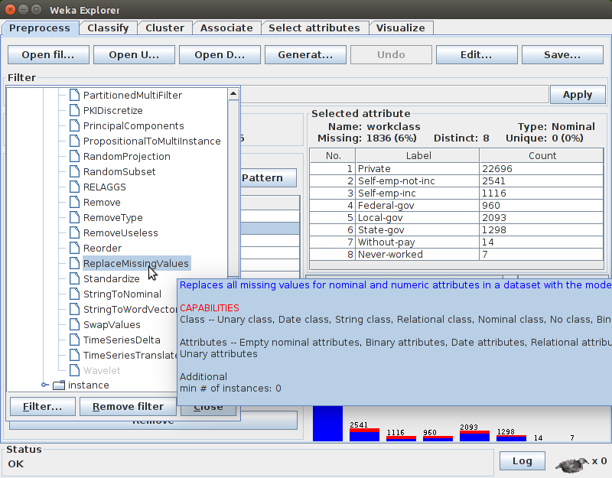
THIS IS NOT SUPPORTED BY OPEN-REFINE.

5.No duplicates

6.Scatter-Plot
Select Vizualize tab
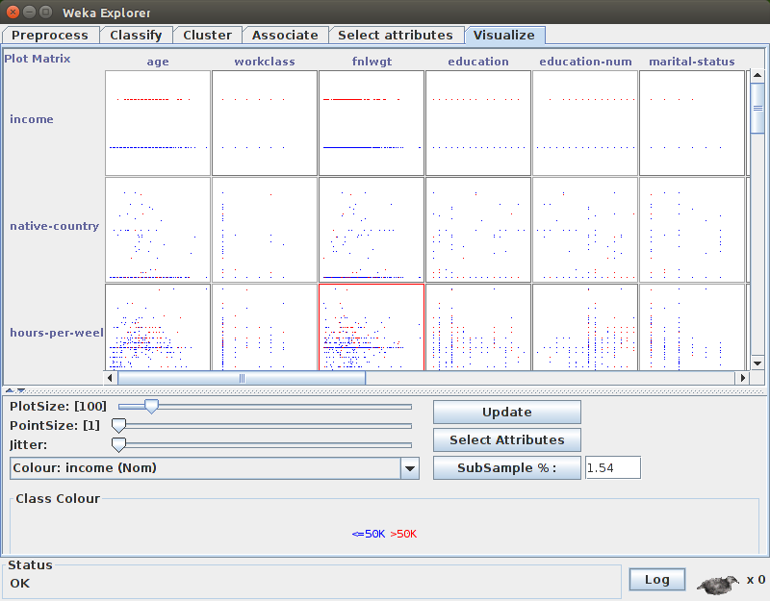

Selecting anyone, we get a clear view and flexibility to change X,Y axes as we wish
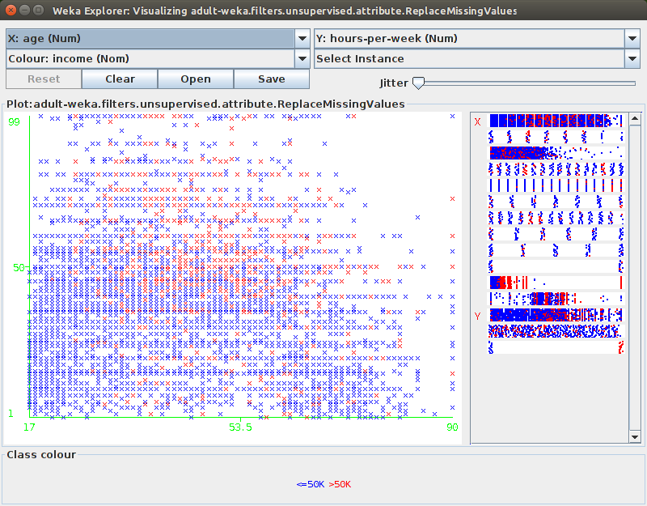
7.Save to an arff file(csv and some other are too supported)
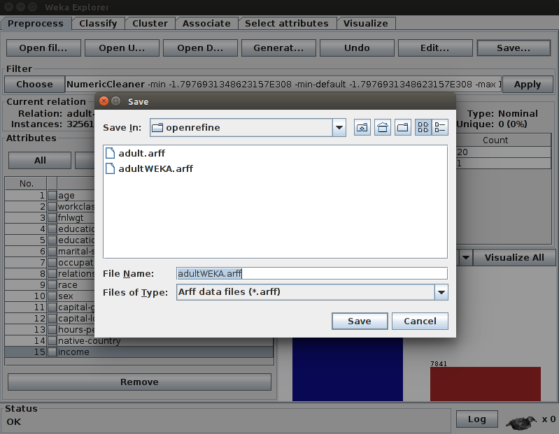

SUMMARY:
Open-Refine cleans data
Weka processes data

